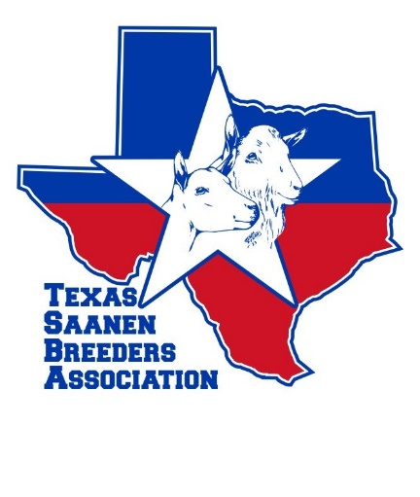
TSBA Membership Application for 2020
$15.00 yearly dues (check or money order accepted)
Please return by January 31, 2020

Name_____________________________________________________________________________

Adddress___________________________________________________________________________

City___________________________________________State___________Zipcode_______________

Phone______________________________Herdname_______________________________________

Email address________________________________________________________________________

Website_____________________________________________________________________________
Do you want your contact information to be listed on the TSBA website under member/breeder??
Yes No
I authorize the use of membership information as well as photos submitted by me or taken at a TSBA function.
Signature___________________________________________________________Date______________
Please email Pat Thornton at texaastdairy@sbcglobal.com for the mailing address. Thanks you.

